Attention Is All You Need

1 Introduction

Recurrent models typically factor computation along the symbol positions of the input and output sequences.

2 Background

Self-attention, sometimes called intra-attention is an attention mechanism relating different positions of a single sequence in order to compute a representation of the sequence.

3 Model Architecture

Most competitive neural sequence transduction models have an encoder-decoder structure. Here, the encoder maps an input sequence of symbol representations (x1; :::; xn) to a sequence of continuous representations z = (z1; :::; zn). Given z, the decoder then generates an output sequence (y1; :::; ym) of symbols one element at a time. At each step the model is auto-regressive, consuming the previously generated symbols as additional input when generating the next.

3.1 Encoder and Decoder Stacks

3.2 Attention

An attention function can be described as mapping a query and a set of key-value pairs to an output, where the query, keys, values, and output are all vectors. The output is computed as a weighted sum of the values, where the weight assigned to each value is computed by a compatibility function of the query with the corresponding key.

3.2.1 Scaled Dot-Product Attention

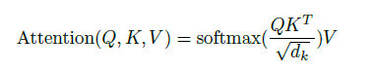

3.2.2 Multi-Head Attention

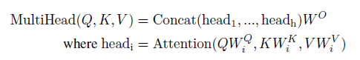

3.2.3 Applications of Attention in our Model

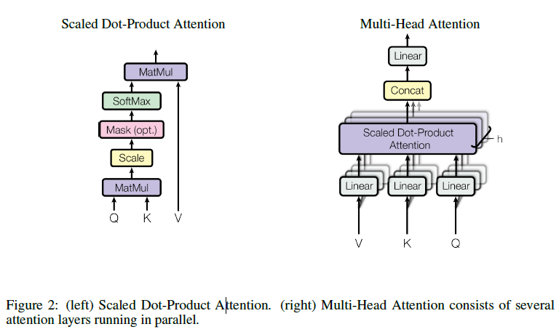

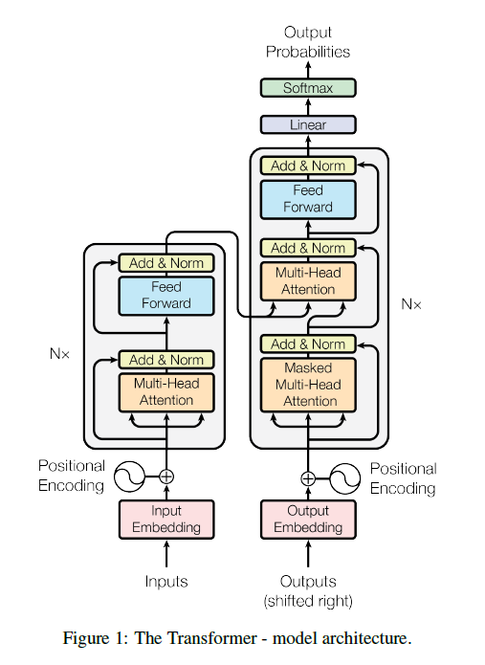

3.3 Position-wise Feed-Forward Networks



3.4 Embeddings and Softmax

3.5 Positional Encoding

Since our model contains no recurrence and no convolution, in order for the model to make use of the order of the sequence, we must inject some information about the relative or absolute position of the tokens in the sequence.

4 Why Self-Attention

As side benefit, self-attention could yield more interpretable models. We inspect attention distributions from our models and present and discuss examples in the appendix. Not only do individual attention heads clearly learn to perform different tasks, many appear to exhibit behavior related to the syntactic and semantic structure of the sentences.

5 Training

5.1 Training Data and Batching

5.2 Hardware and Schedule

5.3 Optimizer

5.4 Regularization

We employ three types of regularization during training:

Residual Dropout

Label Smoothing

6 Results

6.1 Machine Translation

6.2 Model Variations

To evaluate the importance of different components of the Transformer, we varied our base model in different ways, measuring the change in performance on English-to-German translation on the development set, newstest2013.

6.3 English Constituency Parsing

To evaluate if the Transformer can generalize to other tasks we performed experiments on English constituency parsing. This task presents specific challenges: the output is subject to strong structural constraints and is significantly longer than the input. Furthermore, RNN sequence-to-sequence models have not been able to attain state-of-the-art results in small-data regimes.

7 Conclusion

In this work, we presented the Transformer, the first sequence transduction model based entirely on attention, replacing the recurrent layers most commonly used in encoder-decoder architectures with multi-headed self-attention.